**DDoS Protection System for Cloud: Architecture and Tool**

|  |  |  |
| --- | --- | --- |
| **Guide Name** | | **Panel Head** |
|  | Dr. Balaji Srikaanth P | Dr. Vinoth Kumar S |
|  |  |  |
|  | **Faculty Advisor** | **Project Domain** |
|  | Dr. G. Suseela | Research |
| M |  |  |
|  | **Student(s) Details: Name** | **Passport size photo(s)** |
|  | 1. Shaurya Singh Srinet 2. Shounak Chandra 3. Charvi Jain |  |
|  |  |  |

Registration Number(s)

1. RA2111032010006

2. RA2111032010026

3. RA2111047010113



**Email ID(s)&Mobile Number(s)**

|  |  |
| --- | --- |
| 1: [sn0273@srmist.edu.in](mailto:sn0273@srmist.edu.in) & +919999847323 | 2: [ss4958@srmist.edu.in](mailto:ss4958@srmist.edu.in) & +919674617402 |
| 3: [ca4617@srmist.edu.in](mailto:ca4617@srmist.edu.in) & +916239884789 |  |

**Abstract Architecture Diagram**

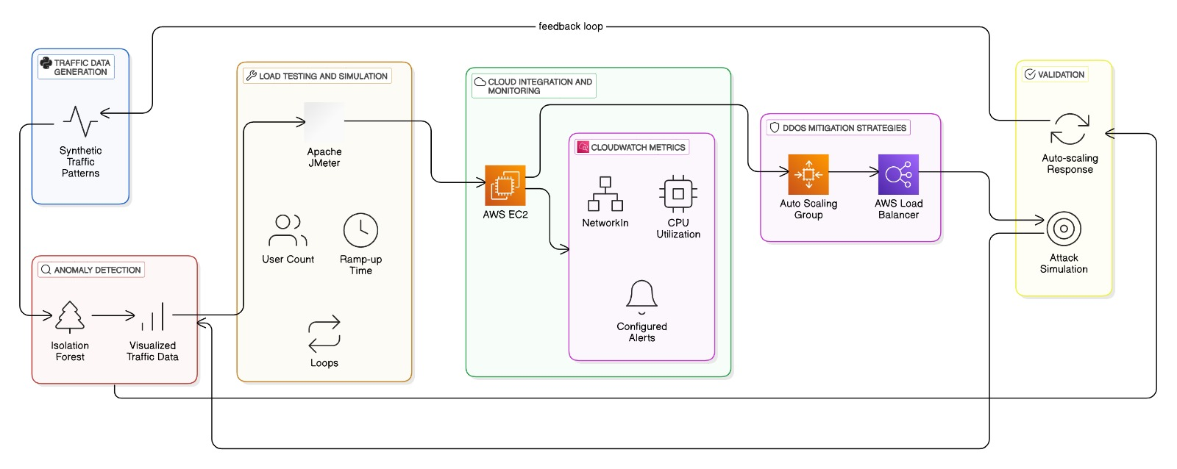

Distributed Denial of Service (DDoS) attacks have emerged as a critical threat to cloud-hosted services, causing severe disruptions and financial losses. This project, Architecture DDoS Protection System for Cloud: Architecture and Tool, focuses on designing a robust and scalable system to detect and mitigate DDoS attacks in real time. The proposed solution integrates advanced traffic analysis, machine learning techniques, and dynamic scaling mechanisms to ensure seamless service availability under attack conditions. By leveraging cloud-native tools and frameworks, this system aims to provide a cost-effective, adaptive defense mechanism suitable for hybrid and multi-cloud environments.

**Significance of the Project Conclusion**

This project addresses a critical gap in cloud security by providing a scalable and adaptive DDoS protection solution tailored for modern cloud architectures. It combines cutting-edge technologies such as machine learning, anomaly detection, and traffic monitoring to ensure service continuity, even under severe attack conditions. The significance lies in its practical applicability for hybrid and multi-cloud environments, offering a cost-efficient defence mechanism while reducing operational complexities. Furthermore, the project contributes to the growing need for robust security frameworks, enabling organizations to safeguard their assets and maintain trust in cloud computing systems.

The Architecture DDoS Protection System for Cloud: Architecture and Tool successfully addresses the challenges posed by Distributed Denial of Service (DDoS) attacks in cloud-hosted environments. By integrating AI-based detection, traffic filtering, and scalable resource allocation, the proposed solution ensures high availability and reliability of services even during intense attack scenarios. This project not only demonstrates the feasibility of leveraging advanced technologies for real-time mitigation but also highlights the potential for further optimization through continuous learning and adaptation. As cloud adoption increases, this system provides a robust framework for organizations to enhance their security posture, ensuring uninterrupted operations and user trust.

**Conference/Journal Publication Details (Mandatory)**

The 3rd International Conference on Futuristic Technologies (INCOFT) 02/21/2025 Pune, Maharashtra, India https://incoft.org/